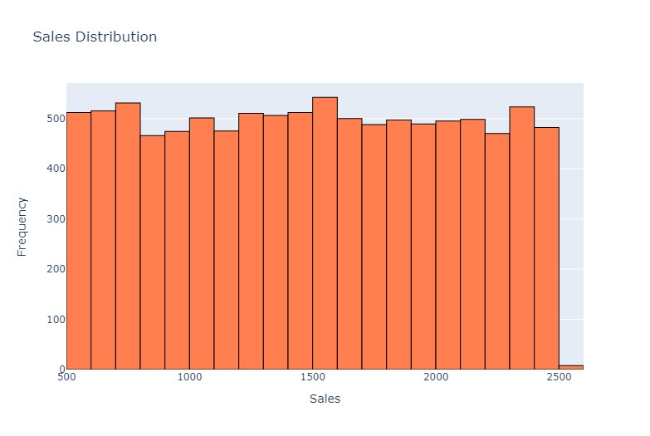

**Spread:**The sales data spans a wide range, from approximately 500 to 2500.This indicates significant variability in sales figures.

**Extreme Points:**

**Lowest Frequency**:The lowest frequency occurs at sales values around 466and sales between 800 and 899.

**Highest Frequency:**The highest frequency is observed at approximately 542 and again at around 1500-1600.

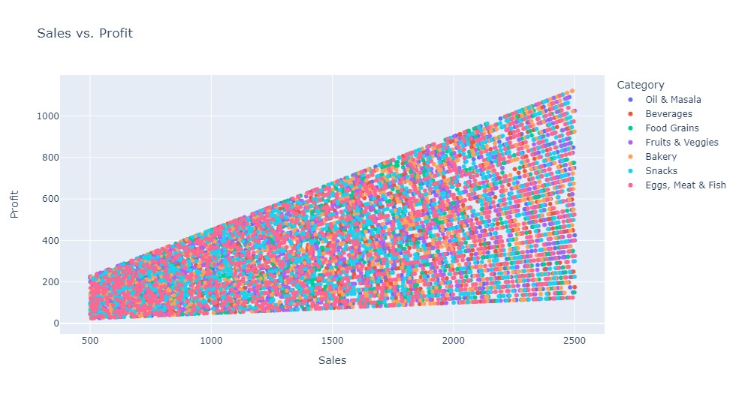

**scatter plot of sales vs. profit**

**Spread:**The data points are spread across the following ranges:

**Sales:** From approximately 0 to around 2500.

**Profit:** From 0 to approximately 1000.

The dense concentration of data points in the lower sales and profit region suggests that many transactions result in lower sales and profits.

|  |  |  |
| --- | --- | --- |
| Category | Sales | Profit |
| Oil & Masala | 2478 | 1100 |
| Beverages | 2413 | 1086 |
| Food grains | 2471 | 1086 |
| Fruits and vegetables | 2465 | 1085 |
| Bakery | 2491 | 1121 |
| Snacks | 2450 | 1102 |
| Eggs ,Meat and Fish | 2265 | 1102 |

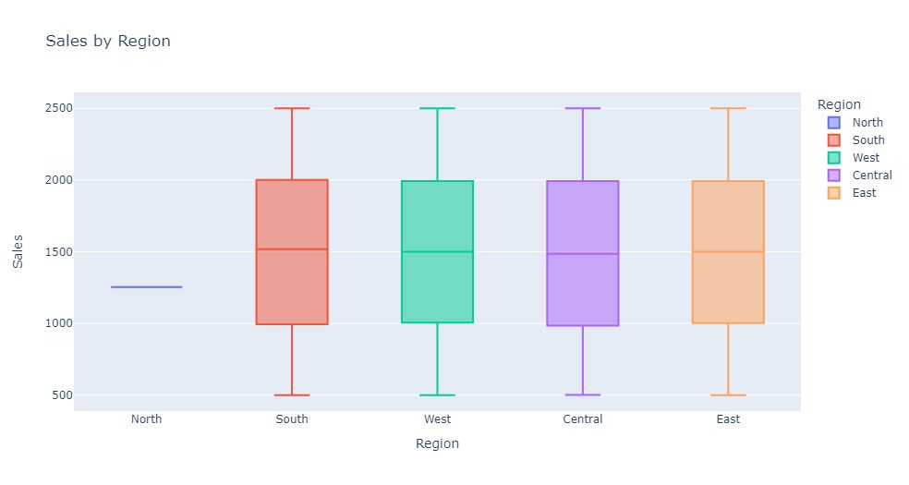

**Box plot of sales by region**

|  |  |  |  |
| --- | --- | --- | --- |
| Region/Sales | Max | Medium | Min |
| South | 2500 | 1571 | 500 |
| West | 2500 | 1500 | 500 |
| Central | 2500 | 1486 | 500 |
| East | 2500 | 1500 | 500 |

**From the above table South Region have Maximum Sales and Central Region has Minimum Sales and North region have no sales.**

# **Analyze sales and profit by region**

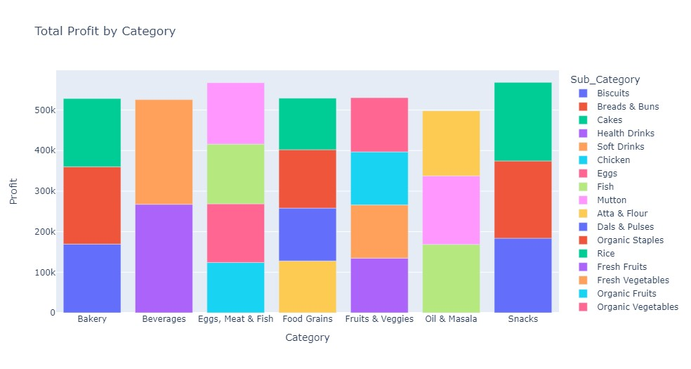

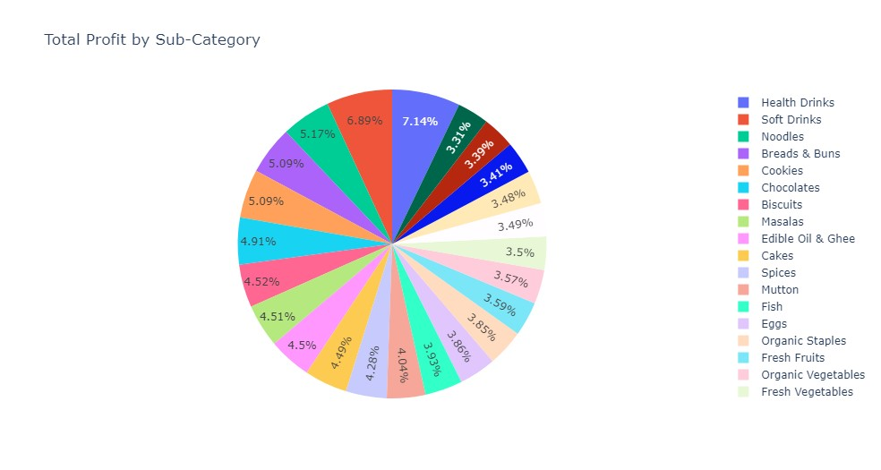

**Data Description:**

The pie chart represents the distribution of total profits across various sub-categories.

Each segment corresponds to a specific sub-category, and the colors differentiate them.

**Spread:-**

The spread refers to how profits are distributed among the sub-categories.

We have a total of 23 sub-categories represented in the chart.

**Highest Profit:-**

The sub-category with the highest profit is Health Drinks, contributing 7.36% to the total profits.

**Lowest Profit:-**

The sub-category with the Lowest profit is Rice, contributing 3.49% to the total profits.

**Data Inference :**

**Health Drinks:**Leading in profits, suggesting they might be popular or high-margin items.

**Organic Fruits & Rice:** Contributing the least to profits; strategies to enhance their sales or margins could be beneficial.

**Other Significant Contributors:**

Soft Drinks, Noodles, and Breads & Buns also have substantial contributions.

Analyzing sales patterns for these categories could provide insights for boosting overall profitability.

# **Analyze sales and profit by region**

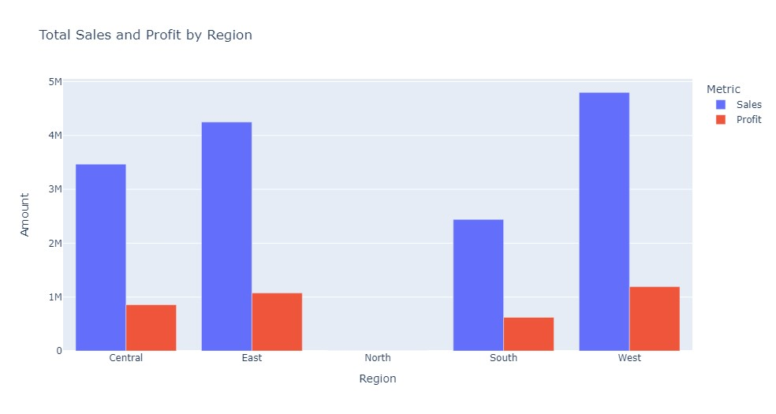

|  |  |  |  |  |
| --- | --- | --- | --- | --- |
| Region | Profit | Sales | Spreads: Sales in x times Profit | Inference |
| Central | 857K | 3.46M | 4 | high sales but a relatively lower profit margin. |
| East | 1.07M | 4.24M | 4 | performs well in both sales and profit. |
| South | 624K | 2,44m | 4 | needs improvement in profitability. |
| West | 1.192M | 4.8M | 4 | the most successful in terms of both sales and profitability. |

**From the above diagram West region have highest Profit over Sales and North region have no Sales and Profit.**

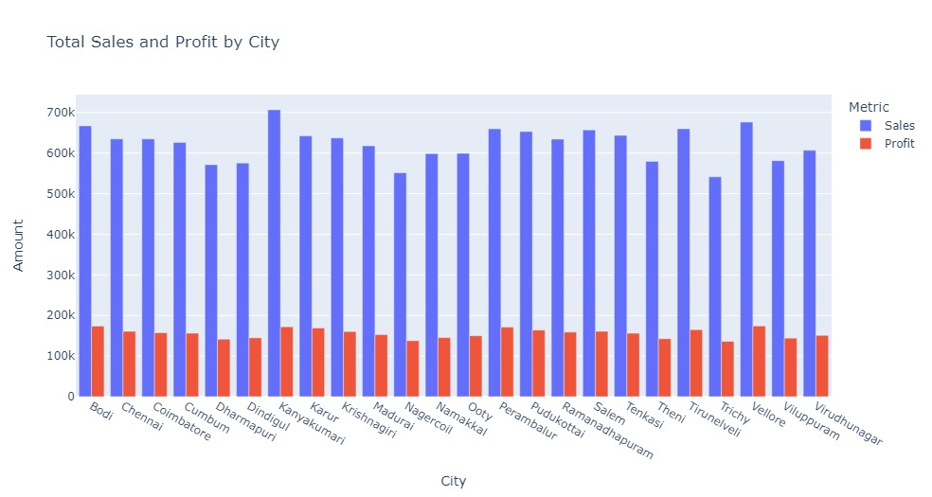

# **Analyze discounts**

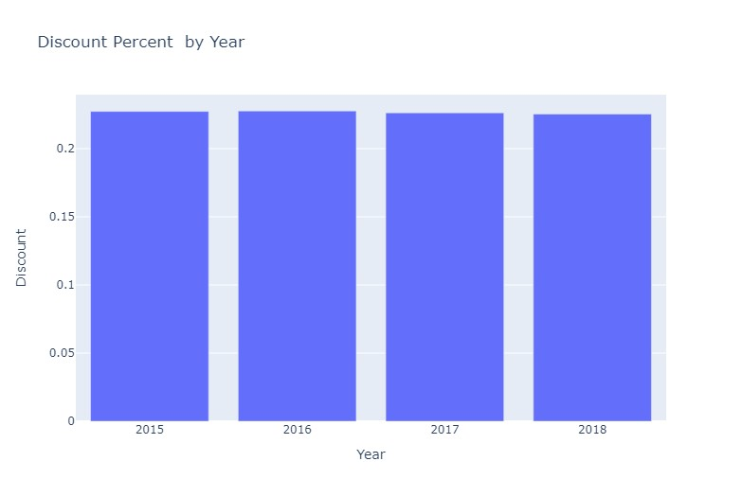

**Spread:**

The discounts are consistently around 22%, with minimal fluctuation.

The spread between the discount percentages is relatively small.

**Extreme Points:**

**Lowest Discount: In 2018, the discount percentage is 22.53%.**

**Highest Discount: In 2016, the discount percentage reaches 22.76%.**

**Average Value:**

**The average discount over these four years is approximately 22.66%.**

Bar chart for discount percent by year.

|  |  |  |
| --- | --- | --- |
| Year | Discount(in %) | Inference |
| 2015 | 22.73 | Slightly below average, indicating a conservative approach to discounts. |
| 2016 | 22.76 | suggesting an aggressive promotional strategy. |
| 2017 | 22.62 | indicating a pullback in discounts offered. |
| 2018 | 22.53 | an effort to stabilize or boost profit margins. |

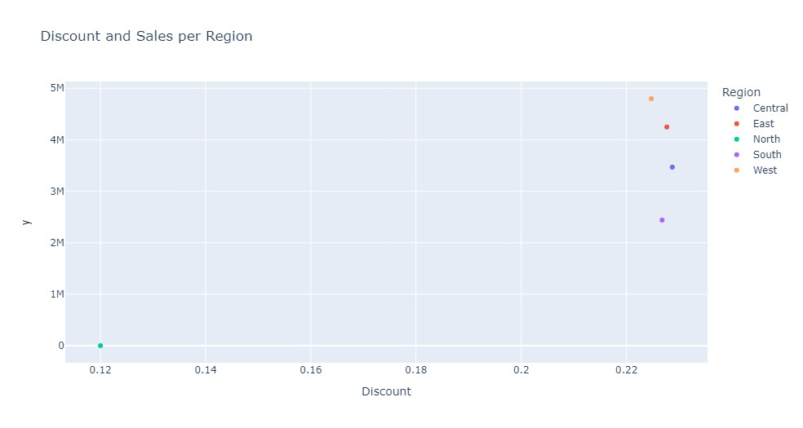

scatter plot for discount and sales per region.

From the Discount and Sales per Region scatter plot, we can see that the South region has the highest discount percent and sales, while the Central region has the lowest discount percent and sales.

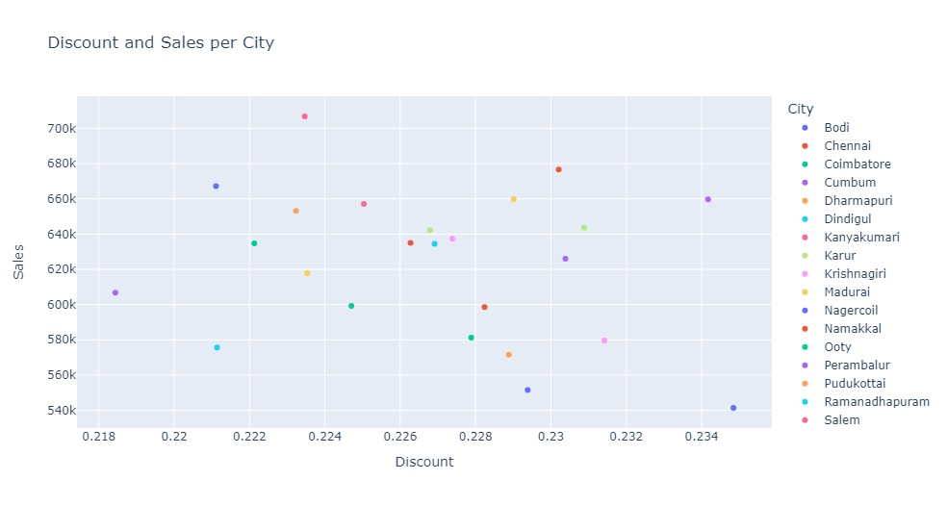

### From the Discount and Sales per City scatter plot, we can see that the cities with the highest sales and discount percent are Krishnagiri and vellore, while the city with the lowest sales and discount percent is Trichy.

# **Analyze discounts and their impact on profit**

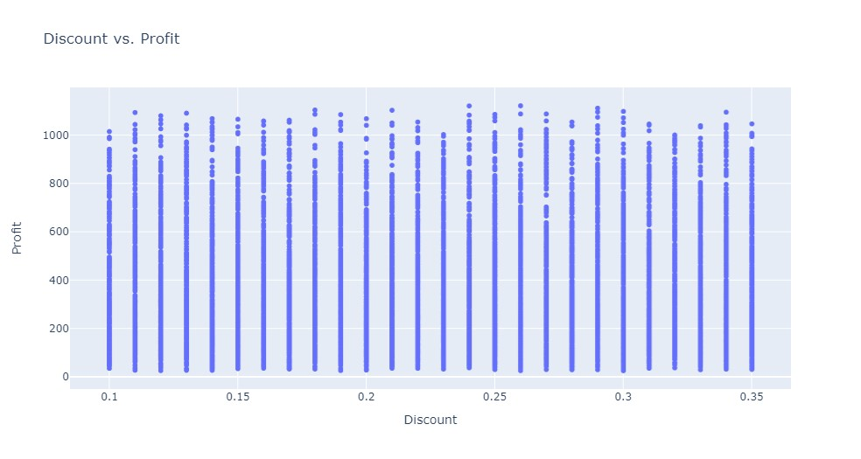

From the results of the analysis, we might find that certain categories or sub-categories have higher sales and profits than others, and that discounts have a negative impact on profit. Based on these findings

Recommendations:

a. Adjust Discount Strategy: Reduce discounts or change strategies to preserve or enhance profit margins.

b. Promotional Focus: Direct promotions towards high-performing categories/sub-categories to maximize sales and profits.